**Themes overview**

In Power Apps portals, the **Enable basic theme** feature is set to **Off**. When you turn on this feature, you can use default themes called **Presets**. You can also create copies of the preset themes for additional customization.

## Enable basic themes for existing portals

1. Sign in to [Power Apps](https://make.powerapps.com/).
2. Select **Apps** from the left navigation pane, and then select the portal.

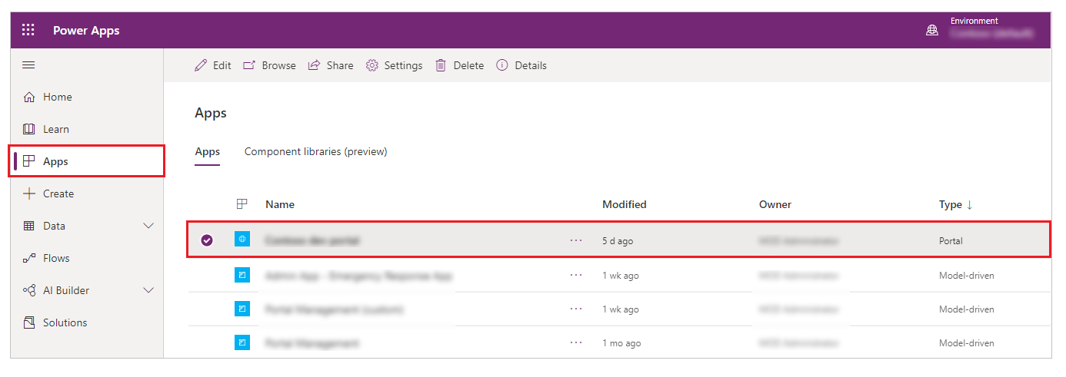

1. Select **More Commands** (**...**), and then select **Edit**.

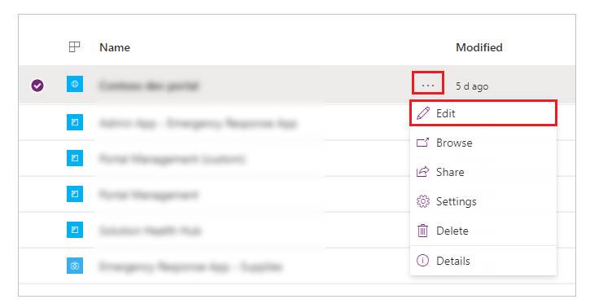

1. Select **Themes** from the left navigation pane, and then turn on the **Enable basic theme** toggle.

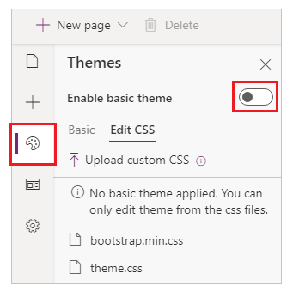

## Change theme for your portal

You can set any existing theme in your portal to a default theme.

1. Sign in to [Power Apps](https://make.powerapps.com/).
2. Select **Apps** from the left navigation pane, and then select the portal.
3. Select **More Commands** (**...**), and then select **Edit**.
4. Select **Theme** from the components pane.

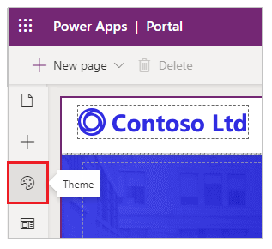

1. Select any default theme from the available presets (in our example, we selected **Green**).

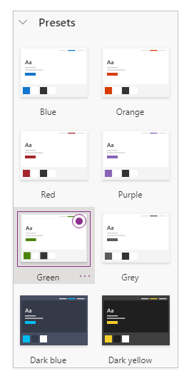

The selected theme is applied to your portal.

